# AutoTest Studio Getting started tutorials 1: Get started with AutoTest Studio

**Introduction to AutoTest Studio**

AutoTest Studio is an excellent software automation testing platform, using python language as the use case writing language, integrating use case development, debugging, management, task scheduling, automatic generation of test logs and test reports and other functions, meeting the automation implementation needs of most projects , And it is free. Compared with other similar automated testing frameworks, such as Robot Framework and TestNg, it is more flexible and simple, and does not require manual installation of numerous dependent packages and complex environment setup.

Official website：<https://www.autoteststudio.com/>

Download URL：<https://www.autoteststudio.com/?page_id=1259>

The latest version is 2.0.3.

Main features：

**Logs and Reports**

The test log records the details of the test case run, and the test report can count the results of the test case execution in each test task and present it as a chart.

[**Data Dictionary**](https://www.autoteststudio.com/?page_id=1258&c=t_008)

AutoTest Studio maintains an independent data configuration file for each test project. Through the data dictionary management tool, you can configure up to millions of data records, and access these datas through API interfaces in test cases.

**Package Manager**

The Python package manager allows you to install,delete,upgrade,import,and export the Python packages through a graphical interface.

**Code Editor**

AutoTest Studio has a professional code editor, which can perform operations, such as keyword highlighting, code folding, expansion, code auto-completion, and code formatting.

**Debugger**

AutoTest Studio integrates a powerful Python Debugger,which makes it easier for you to find exceptions and error messages in program execution.

**Test case Runner**

AutoTest Studio has an advanced task engine that can provide a variety of task execution scheduling methods, such as timed tasks, cyclic execution, and execution of test cases in specified states.

**AutoTest Studio installation and configuration**

After downloading the installation package from the official, click "Next" to easily complete the installation.

After completing the installation, when you run the program for the first time, you will be prompted to configure the python interpreter path. I need to remind that this python interpreter is required for some plug-ins in the background of the program, not the python environment where the project runs. In the second section, I will introduce how to configure The python environment where the project is running.

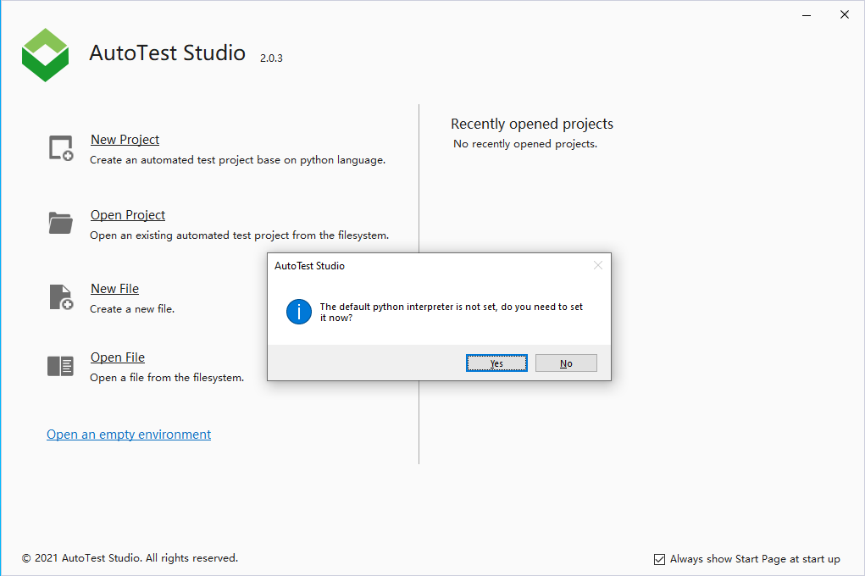

Of course, you can skip it directly and configure it later. Here we follow the prompts to configure the python interpreter.

Click "Add" to add the python interpreter path.

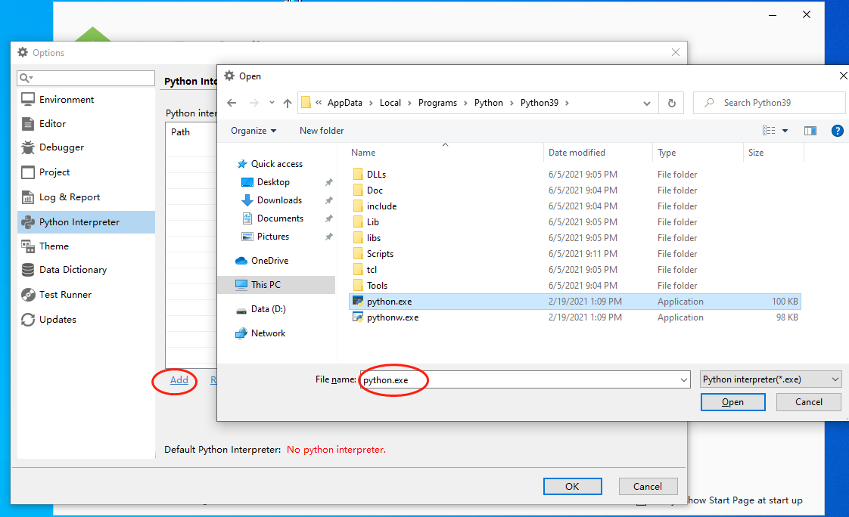

You can add multiple python interpreters here. You can select the python interpreter used by the program by setting the default python interpreter. If you do not set the default python interpreter, you will be prompted whether to set the current python interpreter when adding It is the default python interpreter.

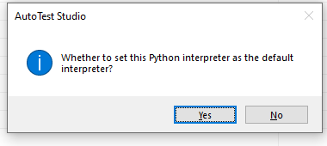

After setting the python interpreter as the default interpreter, the program will automatically check and install the python packages required by the program.

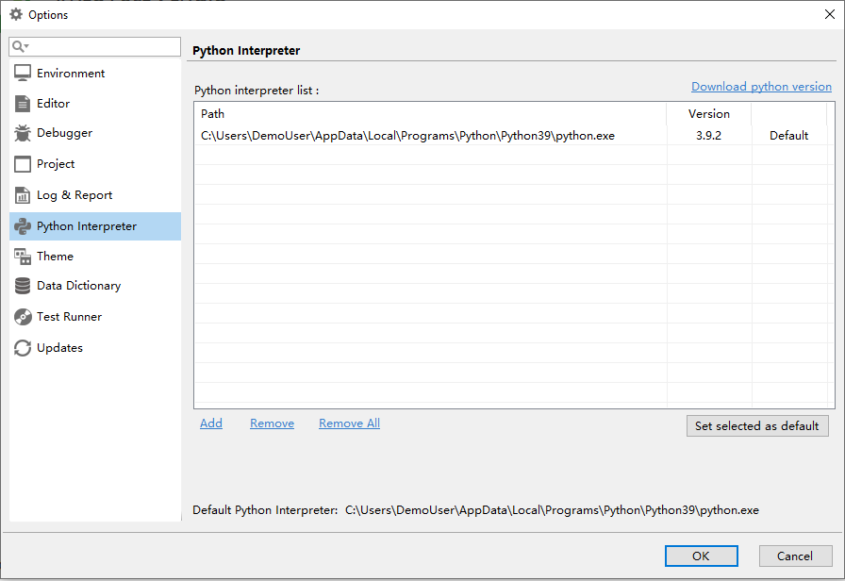

After setting, click OK.

At this point, the installation and basic configuration of AutoTest Studio have been completed.